**Bài Thi cuối kì**

Phần 1:

Code

x=[6,7,8,9]

def not_prime():

if x[0]%2 !=0:

a=print(x[0])

if x[1] %2 !=0:

b=print(x[1])

if x[2] % 2 !=0:

c=print(x[2])

if x[3]%2 !=0:

d=print(x[3])

else:

return

if __name__=="__main__":

not_prime()

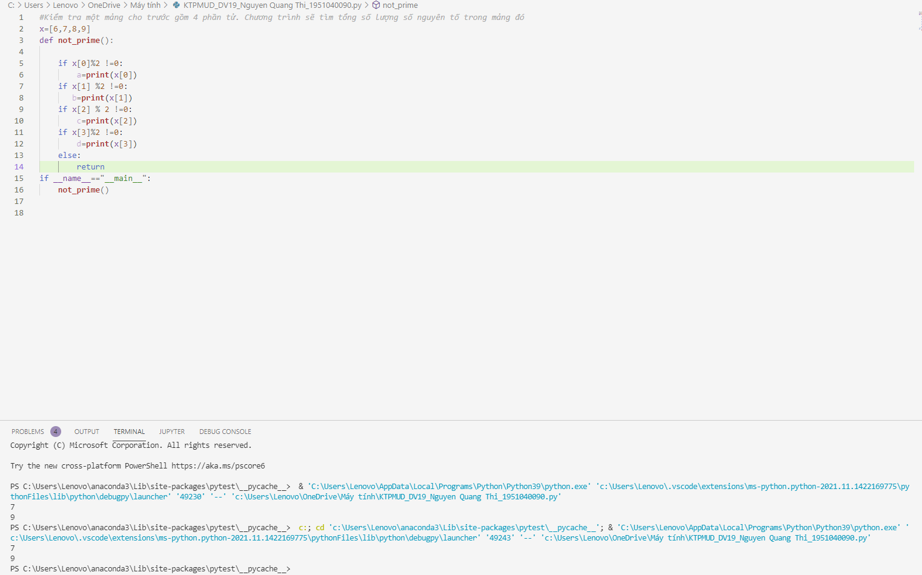

Phần 2:

Câu 1:

Câu 2:

1. select city, SUM(grade) sum_grade

from customer

group by city

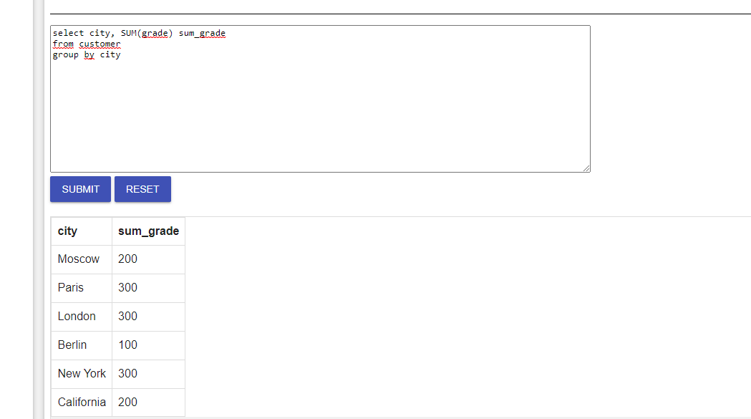

1. select customer_id, name, cust_name, commission

from customer cus

join salesman sal

on cus.salesman_id=sal.salesman_id

where commission >0.12

order by customer_id

